1. **For different category of acquirers, what is the average number of months since the inception of the acquired company after which they are acquired.**

SELECT

acquisitions.acquirer_category_code,

ROUND(AVG((CAST(acquisitions.acquired_at_cleaned AS DATE)-

CAST(companies.founded_at_clean AS DATE))/30)) AS Average_months

FROM

tutorial.crunchbase_acquisitions_clean_date AS acquisitions

LEFT JOIN

tutorial.crunchbase_companies_clean_date AS companies

ON

acquisitions.company_permalink=

companies.permalink

GROUP BY

acquisitions.acquirer_category_code

ORDER BY

acquisitions.acquirer_category_code

;

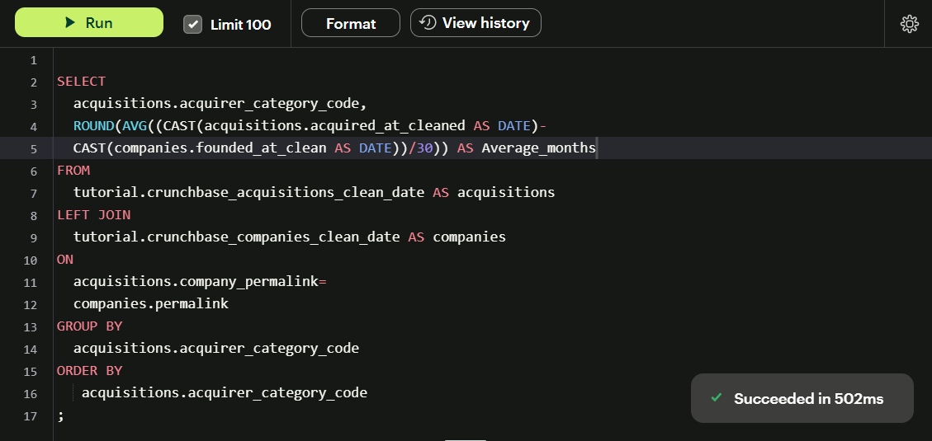

1. **Is there any trend for quarters when more companies are acquired?**

SELECT

SUBSTRING(acquired_quarter,6,2) AS quarter,

COUNT(company_name) AS no_of_companies

FROM

tutorial.crunchbase_acquisitions

GROUP BY

quarter

ORDER BY

no_of_companies DESC

;

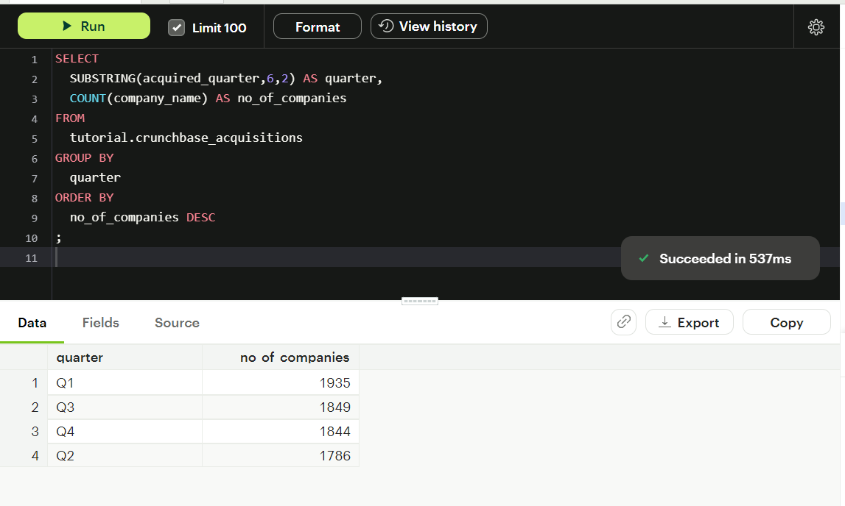

More number of companies are acquired in the odd quarters.

1. **For each company_category_code identify the average raised_amount_usd per quarter.**

SELECT

company_category_code,

(SELECT

ROUND(AVG(raised_amount_usd))

FROM tutorial.crunchbase_investments

WHERE investments.company_category_code=company_category_code

AND SUBSTRING(funded_quarter,6,2)='Q1') AS Q1_Avg_raised_amt,

(SELECT

ROUND(AVG(raised_amount_usd))

FROM tutorial.crunchbase_investments

WHERE investments.company_category_code=company_category_code

AND SUBSTRING(funded_quarter,6,2)='Q2') AS Q2_Avg_raised_amt,

(SELECT

ROUND(AVG(raised_amount_usd))

FROM tutorial.crunchbase_investments

WHERE investments.company_category_code=company_category_code

AND SUBSTRING(funded_quarter,6,2)='Q3') AS Q3_Avg_raised_amt,

(SELECT

ROUND(AVG(raised_amount_usd))

FROM tutorial.crunchbase_investments

WHERE investments.company_category_code=company_category_code

AND SUBSTRING(funded_quarter,6,2)='Q4') AS Q4_Avg_raised_amt

FROM

tutorial.crunchbase_investments AS investments

GROUP BY

company_category_code

;

1. **Which investor(company) is more likely to invest in USA based companies?**

SELECT

investor_name, COUNT(company_name) AS number_of_companies_invested_on

FROM

tutorial.crunchbase_investments

WHERE

company_country_code='USA'

GROUP BY

investor_name

ORDER BY number_of_companies_invested_on DESC

LIMIT 1;

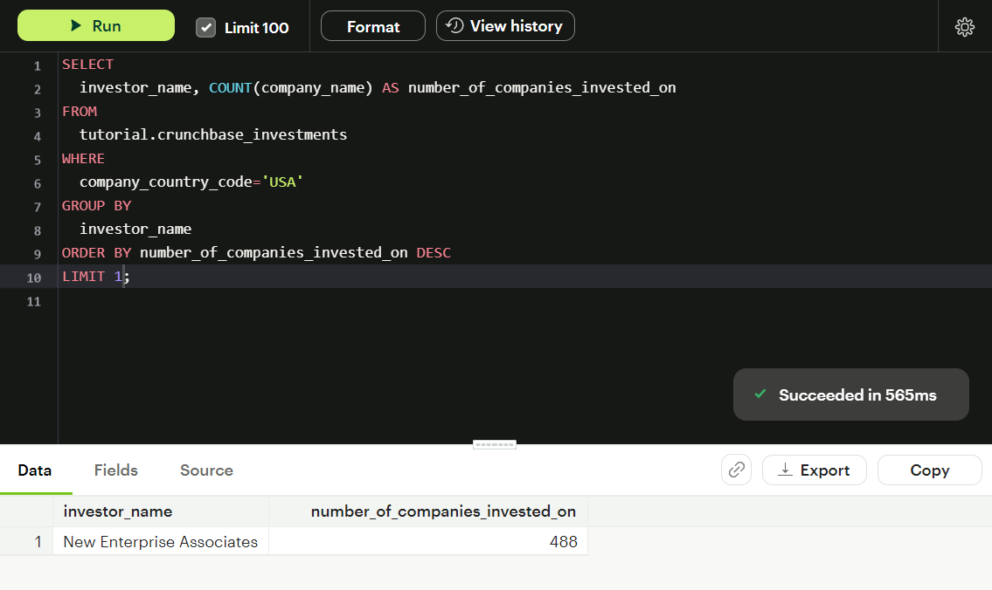

1. **For different type of funding rounds, what is the average raised amount per quarter?**

SELECT

funding_round_type,

(SELECT ROUND(AVG(raised_amount_usd))

FROM tutorial.crunchbase_investments

WHERE investments.funding_round_type=funding_round_type

AND SUBSTRING(funded_quarter,6,2)='Q1') AS Q1_Avg_raised_amt,

(SELECT ROUND(AVG(raised_amount_usd))

FROM tutorial.crunchbase_investments

WHERE investments.funding_round_type=funding_round_type

AND SUBSTRING(funded_quarter,6,2)='Q2') AS Q2_Avg_raised_amt,

(SELECT ROUND(AVG(raised_amount_usd))

FROM tutorial.crunchbase_investments

WHERE investments.funding_round_type=funding_round_type

AND SUBSTRING(funded_quarter,6,2)='Q3') AS Q3_Avg_raised_amt,

(SELECT ROUND(AVG(raised_amount_usd))

FROM tutorial.crunchbase_investments

WHERE investments.funding_round_type=funding_round_type

AND SUBSTRING(funded_quarter,6,2)='Q4') AS Q4_Avg_raised_amt

FROM

tutorial.crunchbase_investments AS investments

GROUP BY

funding_round_type;

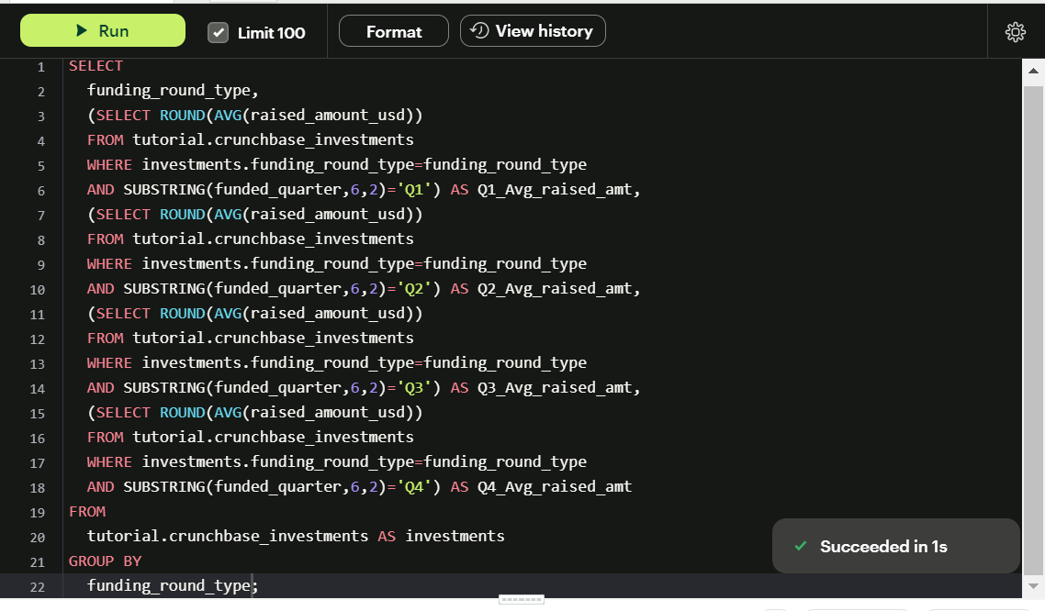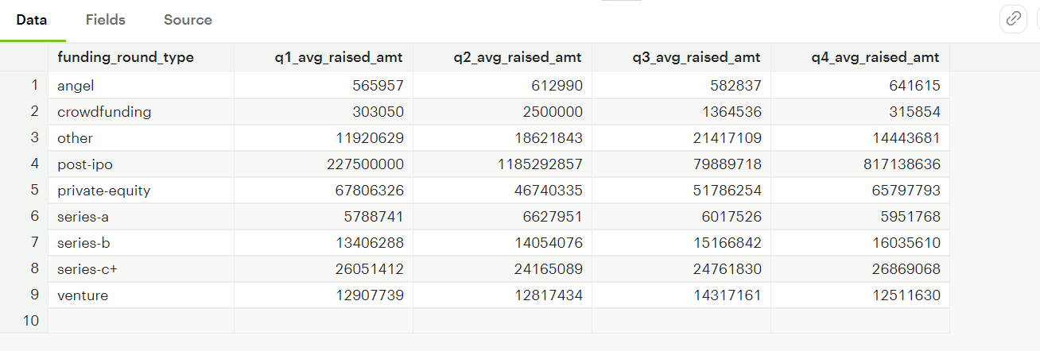

1. **Identify companies that received an investment from Japan following an investment from Great Britain where investor is finance category company.**

SELECT DISTINCT(company_name),curr_investor_country,prev_investor_country,investor_category_code

FROM (SELECT

company_name,

investor_country_code AS curr_investor_country,

CAST(funded_at AS DATE),

investor_category_code,

LAG(investor_country_code)

OVER (ORDER BY CAST(funded_at AS DATE))AS prev_investor_country

FROM tutorial.crunchbase_investments

WHERE investor_country_code IN ('JPN','GBR')

AND investor_category_code='finance'

) AS t

WHERE curr_investor_country='JPN' AND prev_investor_country='GBR';

1. **Out of all ‘operating’ status companies, which category of companies have the highest average funding_total_usd?**

SELECT category_code, ROUND(AVG(funding_total_usd)) AS avg_funding_total

FROM tutorial.crunchbase_companies_clean_date

WHERE status='operating'

GROUP BY category_code

ORDER BY avg_funding_total DESC

LIMIT 1;

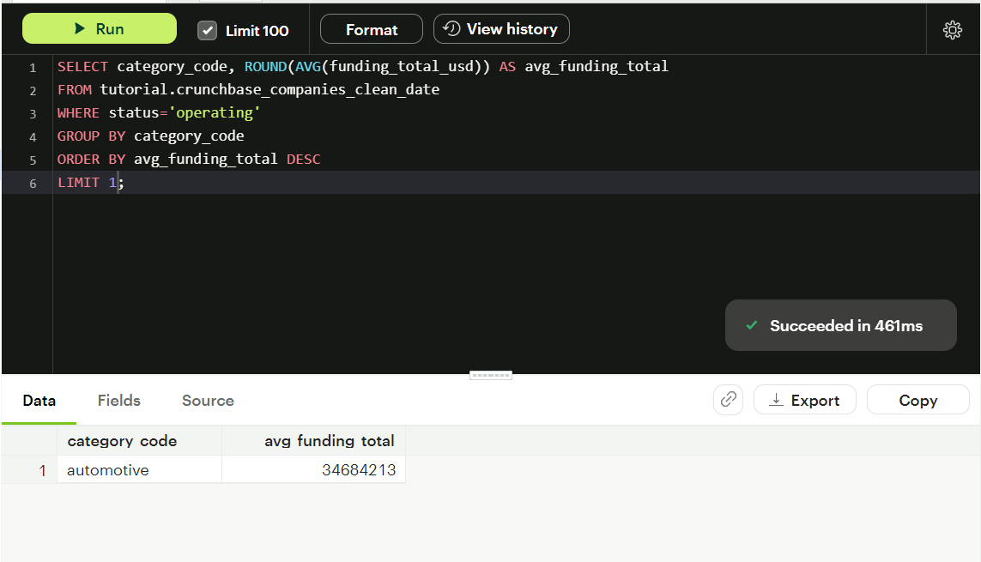

1. **For each category, what percent of companies received funding within 3years of their funding?**

SELECT

category_code,

CASE

WHEN category_code IS NOT NULL

THEN ROUND((cast((SELECT count(DISTINCT name) FROM tutorial.crunchbase_companies AS sub

WHERE sub.category_code = out.category_code

AND (cast(sub.first_funding_at AS date) - cast(sub.founded_at AS date)) < 1095 ) AS float ) /

cast((SELECT count(DISTINCT name) FROM tutorial.crunchbase_companies AS sub

WHERE sub.category_code = out.category_code ) AS float ))*100)

END AS percentage

FROM

tutorial.crunchbase_companies AS out

GROUP BY

category_code;

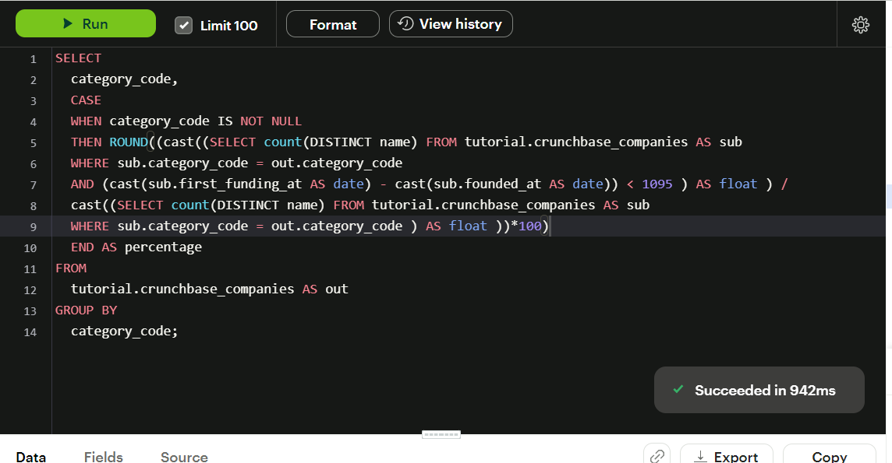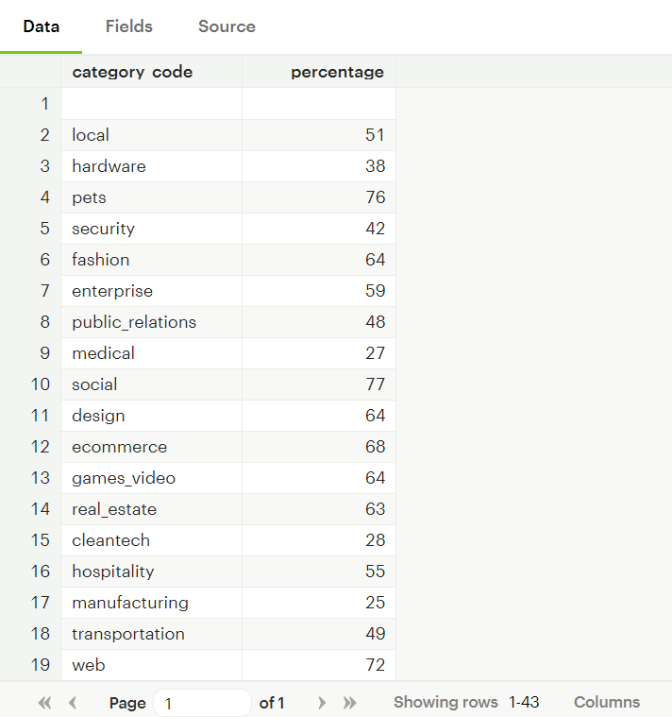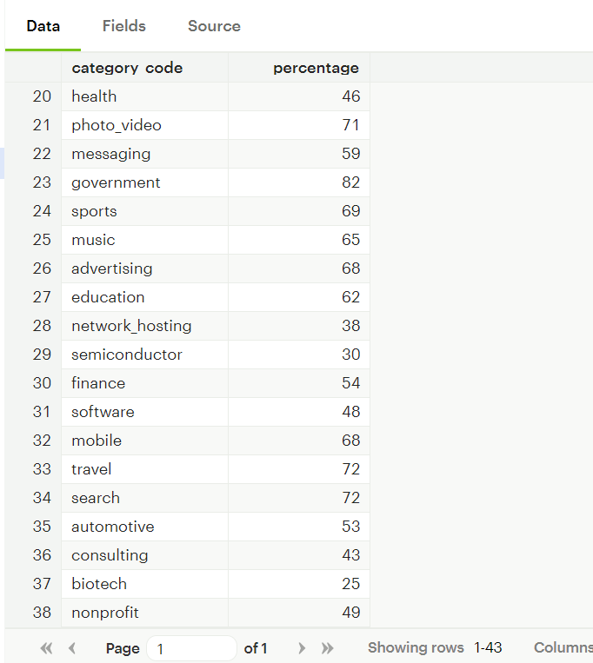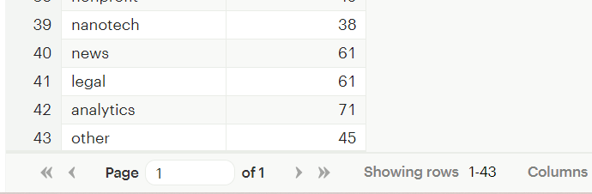

1. **Clean the ‘last_funding_at’ column (convert it to time stamp) and get the time difference with the current time.**

SELECT

CAST(last_funding_at AS TIMESTAMP),

NOW(),

NOW()-CAST(last_funding_at AS DATE) AS difference_in_days

FROM tutorial.crunchbase_companies;

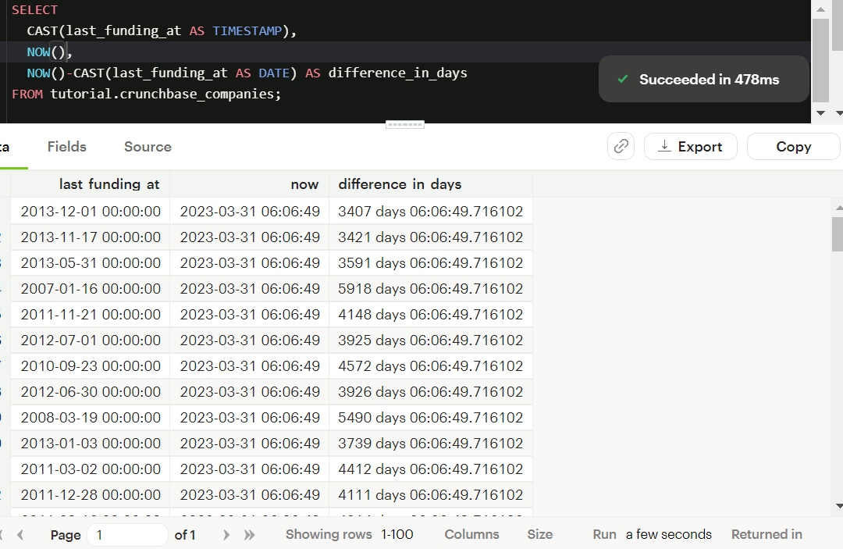

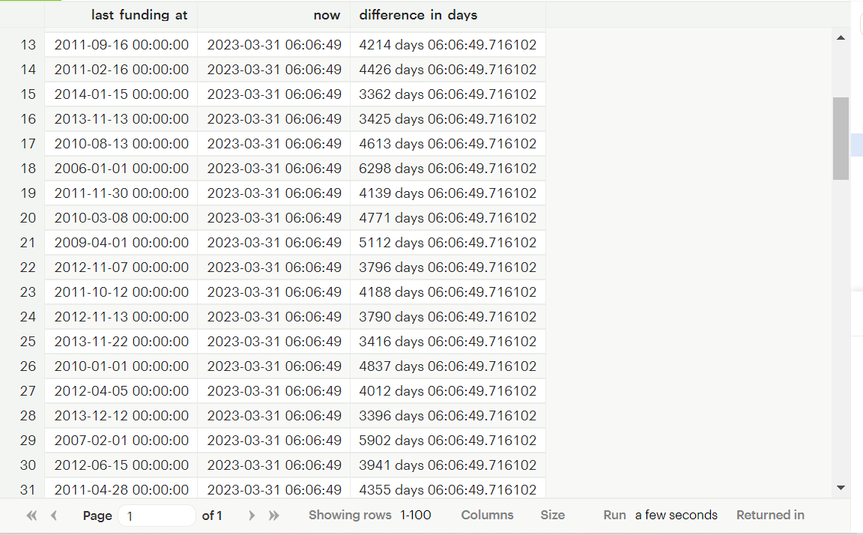

1. **Provide additional analysis based on the data in crunchbase tables.**